ARE YOU RESPONSIBLE FOR LEADING MATHEMATICS INNOVATION AND IMPROVEMENT AT YOUR PLACE?
Mathematics remains a focus for all systems – how will you change the trajectory of your learners?
 | How can you activate and inspire the passionate mathematics educator that lies in each of your staff members?
Are you getting the improvement you want in the learning and teaching of mathematics at your place?  Come and associate with other R-6 leaders to deepen and extend your curriculum leadership capacity… |  | WHAT’S YOUR NEXT CRITICAL STEP? 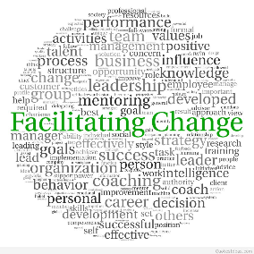

Curriculum leadership matters!

